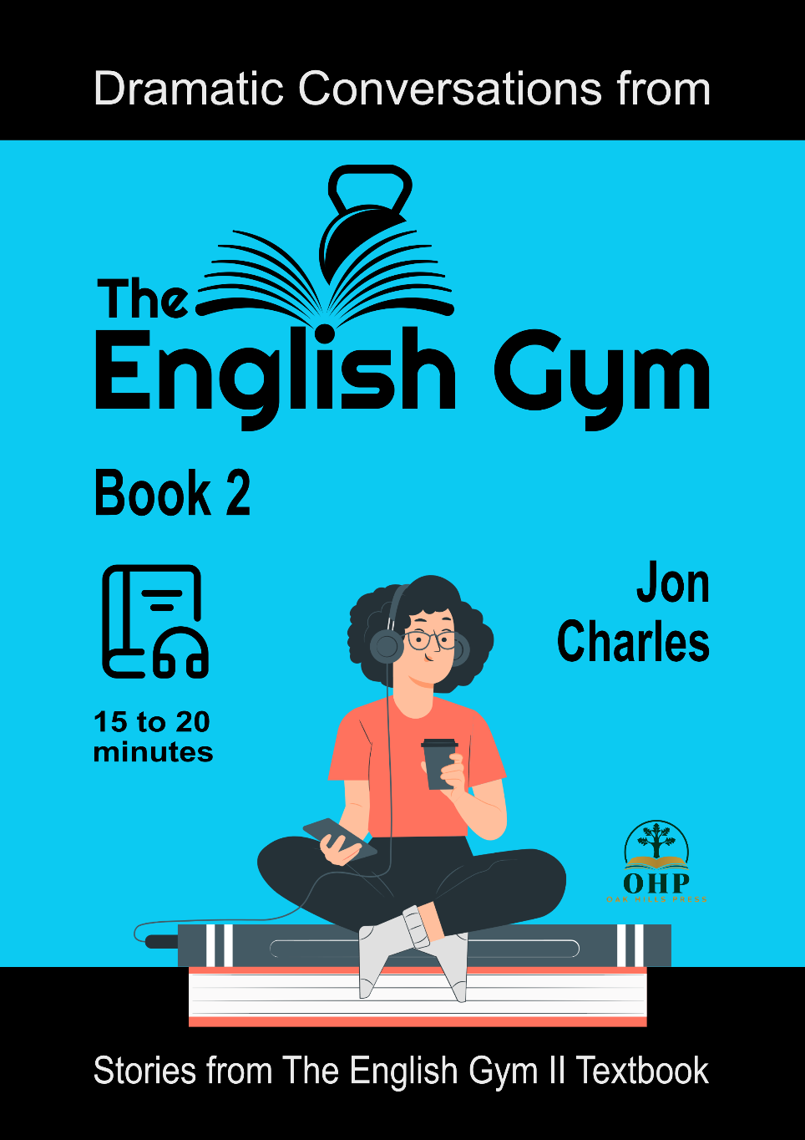
Dramatic conversations from
The English Gym II textbook
by Jon Charles
Book 2
A collection of short dialogues from The English Gym II textbook.
Topics include sharing an apartment, marrying a foreigner, a bucket list, trouble on vacation, driving, a story about a shut-in, and robots.



####
Contents
Introduction
Story 08: Sharing an Apartment
Story 09: Marrying a Foreigner
Story 10: The Bucket List
Story 11: Trouble on Vacation
Story 12: Driving
Story 13: The Story of the Shut-In
Story 14: Robots

####
Introduction

All of the stories in this collection include dramatic audio recordings from the textbook, The English Gym II. It is recommended to listen to the audio as you read.

####

Story 08: Sharing an Apartment

Pre-Reading Vocabulary:
go with your gut = follow your feelings; “gut” means stomach
leftovers = food that has not been finished and is often eaten the next day
*****
Situation:
Two university students, Joe and Paul, have been sharing an apartment for a month. Joe has just come home after classes. Paul is sitting on the sofa, eating pizza and watching TV.

Paul: Hey, Joe! What’s happening?
Joe: Hey, Paul. Well, I think I failed my economics test. It was really hard, and I didn’t study enough.
P: Eh, don’t worry about it. Economics is easy. You gotta go with your gut. If it feels right, do it! Just like the stock market.
J: What do you know about the stock market? You work at a supermarket.
P: Someday, Joe, I’m gonna be rich. Hey, you want some pizza?
J: Sure … Hey, is this the pizza I bought last night? Is this my pizza?
P: Oh, sorry, man. I just saw the leftovers in the fridge, and I thought you wouldn’t mind … .
J: Paul! You can’t just eat my food. This morning, you ate all the cereal, which I bought! And the other day, you drank all the beer, which I bought! And now, you’re eating my pizza!
P: Relax, Joe. I’ll go buy some beer and cereal. It’s not such a big deal.
J: It is a big deal. Look, we share an apartment, but we don’t share the food, ok?
P: Fine! Then how about you clean up your mess! You never wash the dishes in the sink. And you leave your dirty clothes all over the place.
J: What are you talking about?
P: What am I talking about? I’m talking about your socks on the sofa, under the cushions. And I’m talking about your underwear in the bathroom on the floor. And I’m talking about the mold growing from all of your soda bottles that you didn’t finish drinking. It’s gross, man! You live like a pig!
J: Pig?! Who’s the pig? You are eating my pizza!
P: Mmm, it’s really good!
J: Hey! Stop eating my pizza!

####

Story 09: Marrying a Foreigner

Pre-Reading Vocabulary:
head home = go home
come on = an expression used when trying to get agreement or when doubting something
*****
Situation:
An American father is meeting his daughter at an airport in New York. She’s returning home from Japan where she had been teaching English for three years. She has some big news to tell her dad.

Mia: Dad! Dad!
(Waves to her father.)
Father: Mia! Welcome home! You look so good! We missed you so much.
M: I missed everyone, too. Oh, it’s so nice to be home.
F: Well, we’ve got a big party planned for you. I hope you’re not too tired. But your eyes look a little red. Are you OK?
M: I’m fine, Dad. But, um … before we head home, I have something important to tell you.
F: Really? What’s that, Mia?
M: Well, I met a guy … in Tokyo … his name is Daisuke and …
F: Oh, I’m very sorry sweetie. So, you left Japan and had to break up with him, huh? That’s why your eyes are all red.
M: No, no, no, we didn’t break up, Dad. In fact, he asked me to marry him!
F: What?
M: And I said, “Yes”.
F: What?
M: I said, “Yes”.
F: But … but why? How come you didn’t tell us about this guy? Oh, Mia, I was happy for you when you wanted to teach and live in Japan, but marrying a foreigner?
M: Dad, he’s really amazing. He’s so kind and funny. He’s smart and talented. And he really loves me, and I love him.
F: But Mia, he’s not American. Where are you going to live … Japan?
M: Um … maybe, yeah.
F: Oh, come on, this is your home, right here.
M: Dad, “Home is where the heart is”, you are always telling me that. Well, my heart is with Daisuke.
F: Mia, listen to me. Think about what you’re doing. This is too sudden. You need to take a break from Daisu … Daizu …
M: Daisuke! I know it’s sudden for you, but I’ve been dating him for more than a year. Once you meet him, Dad, you’ll see what a great guy he is.
F: I’m not going to Japan to meet him!
M: Oh, that’s OK, he’s coming to America.
F: What? When?
M: Actually, here he comes now! Hey, Daisuke!
(Waves to Daisuke.)

####

Story 10: The Bucket List

Pre-Reading Vocabulary:
philosophy = the study of ideas, and the meaning of life
pencil in = to write something on a list or in a schedule that may be changed
chicken = a term meaning scared
gives me the shivers = makes me feel scared
*****
Situation:
A student is working on his homework when his friend comes in.

Sora: Hey, Nick. What’s up?
Nick: Oh, hi Sora. I’m just doing my philosophy homework.
S: You’re taking a philosophy class? Wow, that’s interesting! What’s your homework? Figure out the meaning of life?
N: Uh..., yeah, kinda like that. There’s actually a lot of reading, you know Socrates, Plato, Confucius. But this week we need to make a bucket list.
S: Is that like a shopping list … for different kinds of buckets? (ha ha)
N: (ha ha) No. It has nothing to do with buying buckets. In English, we have the expression, “to kick the bucket”, which means to die.
S: So, if I “kick the bucket” that means I’m dead?
N: Yep. And a “bucket list” is a list of all the things you wanna do before you die.
S: Before you “kick the bucket”, OK, I see. So, what’s on your list?
N: Well … um, finish university, get a good job, get married, buy a home …
S: You got anything more interesting or unusual?
N: Well, I’m not sure yet. I penciled in bungee jumping and skydiving. I’d like to try them, but I’m kinda chicken.
S: Oh, yeah, they are both scary, but really exciting. I did them both when I was traveling in Thailand. Bungee jumping is definitely scarier, though!
N: Why’s that? Jumping out of a plane seems pretty scary.
S: Yeah, but you jump out of the plane together with the instructor. With bungee jumping, you jump by yourself. I was so scared! I thought I might break my neck or something.
N: Wow! Gives me the shivers just hearing about it.
S: So, when are you gonna try bungee jumping or skydiving?
N: I don’t know. Someday, I guess.
S: You gotta have a plan, man. If you don’t have a time frame and a plan, you are never gonna do it.
N: Yeah, I guess you’re right.

####

Story 11: Trouble on Vacation

Pre-Reading Vocabulary:
it’s really nothing = it’s not special
in case = if (you change your mind)
*****
Situation:
Kairi is a Japanese tourist traveling in New Orleans, Louisiana. She’s sitting at an outdoor café, enjoying a morning cup of coffee and using her smartphone. A man with a big smile approaches her. Kairi puts her phone on the table and talks with the man.

Man: Good morning! It’s a fine day, isn’t it?
Kairi: Yes, it’s a beautiful day.
M: Hey, are you from China?
K: No … .
M: Wait, wait … Korea?
K: No … .
M: Mexico?
K: No!
M: OK, OK … um … Japan?
K: Yes, that’s right.
M: Oh, Japan, huh? Um … Konnichiwa … um … domo arigato, Mr. Roboto! (ha ha) That’s all the Japanese I know.
K: Oh, your Japanese is very good!
M: Well, thank you but it’s really nothing. Hey, are you on vacation here in New Orleans?
K: Yes, I am.
M: Great! I’m a tour guide in this great city, The Big Easy! Do you mind if I show you a brochure?
K: Um … well …
M: Oh, don’t worry. You don’t have to buy anything. I just want to tell you about these amazing steamboat cruises.
K: Well, ok.
(The guide shows Kairi the brochure.)
M: Take a look here. These are beautiful steamboats, and they take you up and down the Mississippi River. There’s live jazz music and great food.
K: It looks fun, but I’m not really interested …
M: Are you sure? We have the best shrimp in all of New Orleans!
K: Thank you but my schedule is full.
M: OK. Well, you have a nice day. I’ll just leave this brochure with you; in case you change your mind.
K: OK. Thank you.
(The guide holds the brochure in front of Kairi’s face, and as he does so, he takes her smartphone.)
M: Sayonara!
K: Goodbye, sayonara!
(Kairi puts the brochure down and notices that her phone is gone!)
K: Hey! Where’s my phone?

####

Story 12: Driving

Pre-Reading Vocabulary:
chauffeur = a paid driver, usually for very rich people
cup of Joe = slang phrase for a cup of coffee
backseat driver = a passenger who gives too much driving advice
out of it = crazy, not aware of the situation
*****
Situation:
Kim has recently passed her driving test and has a new license. Today, Kim is going to take her friend, Steve, for a drive. Steve is waiting outside his apartment as Kim arrives in her car.

Steve: Hey Kim, look at you! Congratulations on getting your license!
Kim: Thanks Steve. I will be your official chauffeur for the day. Are you ready to go?
S: Yes!
(Steve enters the car.)
I’ve always wanted a chauffeur, much better than a taxi!
K: Very good, sir. Where to first?
S: First, Mrs. Bean’s Coffee House. I need my morning cup of Joe!
K: Mrs. Bean’s Coffee House? I’m sorry, sir. I don’t know where that is.
S: What kind of chauffeur are you? (ha ha)
K: I’m a chauffeur who gets lost a lot! (ha ha)
S: OK, no problem. Just turn* right* at the next light*, then head straight*.
K: Gotcha. Turn right, then go straight down the street*.
S: Oh! Better slow down. That light is turning red.
K: I can see that. Are you always such a backseat driver? (ha ha)
S: (ha ha) Only for new drivers. And I’m not in the back seat. I’m right next to you. Oh! The light’s green!
K: Thank you, I know! Boy, you really …
S: Ahhh! Stop!
K: Oh, my gosh!
(Another car suddenly crosses right in front of Kim’s car. Kim hits the brakes, the tires screech. There is almost an accident!)
S: Oh, man! That guy didn’t stop!
K: I know! He just kept going! He ran right through that red light! He could have killed us!
S: Yeah, and he’s still going! He didn’t even notice! Did you get a look at him?
K: I did. He was like a hundred years old! He didn’t see us. He didn’t hear us. I think it’s too dangerous for someone like that to be driving.
S: Yeah. They should have a driving test for old people.
K: Seriously, that guy was really out of it!

####

Story 13: The Story of the Shut-In

Pre-Reading Vocabulary:
nothing to brag about = not special or important
hermit = someone who lives alone and doesn’t see other people, a recluse
geek = someone who is not cool and is interested in things like computers or comic books
*****
Situation:
A man in his 30's has become a shut-in in his parent’s home. A friend from his high school days comes to visit to talk with him.

Gary: So, Paul, I see you’ve moved down to the basement, huh? How’s life, man? I haven’t seen you in over ten years.
Paul: Yeah, well, this is my life. Nothing to brag about, is it? I basically just order pizza, sometimes Chinese, play video games and surf the internet.
G: Wow. I don’t mean to be rude, but how did you end up staying with your parents and becoming such a hermit? No one ever hears from you. You were such a smart kid in high school.
P: Well, I got accepted into Columbia in my senior year of high school and was really excited to go.
G: What? No way! That’s one of the best schools in the country, Paul!
P: Yeah, I was pretty happy about going there. I was planning to be a computer science major.
G: Yeah, I remember in high school, you were always such a geek!
P: I’m still pretty much a geek, but the classes at Columbia were too hard and I couldn’t adjust to living in New York. I failed almost all my classes. Then, after a year, I just gave up and came home. I had a lot a debt, too. It was such a waste of time and money.
G: So, did you start working or something?
P: No. I just got really depressed. I tried to make some money on YouTube, but I couldn’t get any followers. I don’t have the personality for that.
G: Yeah, it’s tough. That kind of thing isn’t for everyone.
P: Hey, Gary, thank you so much for coming to see me today. I know my mom called you and asked you to come.
G: No problem, Paul. I’m happy to see you again. Hey, let’s get out of this house for a while. How about going out for lunch, huh? Pizza or Chinese? You pick!

####

Story 14: Robots

Pre-Reading Vocabulary:
give me the creeps = make me feel uncomfortable and nervous
fender bender = a small car accident, with only slight damage
*****
Situation:
It’s 50 years in the future. Robots are everywhere. They pick up trash in the streets, patrol the neighborhoods and help clean up around our homes. Some people think robots solve problems; others think they are the problem.

Max: Did you see the robot in the street today? It cleaned the whole street in under thirty minutes.
Sarah: Yeah, I saw it. I hate those things.
M: Why? What’s to hate about them?
S: Remember when we actually did those jobs for ourselves? Nowadays people are so lazy because they rely on robots.
M: I do remember. I remember shoveling the driveway in the winter and mowing the lawn in the summer. Now, my yard robot does those things for me. It’s fantastic!
S: I don’t think it’s such a great thing. I think it’s making future generations even lazier.
M: Maybe, but it’s helping me out a lot.
S: And here’s the other thing, all those robots have cameras. They record everything. There’s no more privacy!
M: Well, they keep the streets safe. I’m not a criminal. I don’t have anything to hide. Do you?
S: No! I’m not a criminal, either! But still, they give me the creeps! They’re always watching us, recording everything we do.
M: Well, robots do all the jobs that we don’t like to do. They definitely make our lives easier. I can’t imagine a world without robots.
S: I’m not so sure it’s such a good trade-off. I can’t even drive my own car anymore. My car drives me!
M: That’s definitely a good thing. I remember when you drove your own car. You were dangerous! (ha ha)
S: Hey! I never had a major accident, just a few fender benders!

####

Thank you for reading (and listening)
If you liked these conversations, there are two more books of conversation from The English Gym.
Visit our website for information about The English Gym textbooks.
https://www.englishgymjapan.com/

####
Copyright © 2022 Oak Hill Press
All rights reserved. No part of this book may be reproduced, stored in a retrieval system, or transmitted in any form by any means, electronic, mechanical, photocopying, recording or otherwise, without prior permission in writing from the author. This is a work of fiction. Any resemblance to actual people (living or dead), businesses, or events is purely coincidental.

Image credits: CC0
Cover images from Storyset.com
Story images from Freepik.com: 8, 12, 13 – Way Home Studio; 9 – V. Ivash; 10, 11 – Benzoix; 14 – Macrovector

Background music credits: CC BY 4.0
Freemusic archive.com
Doctor Turtle:
Story 9, 13 “The Void Says Hi”
Story 8, 10, 12, 14 “Lullaby for Democracy”
Kevin MacLeod:
Story 11 “Off to Osaka”

Voice actor credits: Mason Born, Shelby Baum, Melissa Harlow

